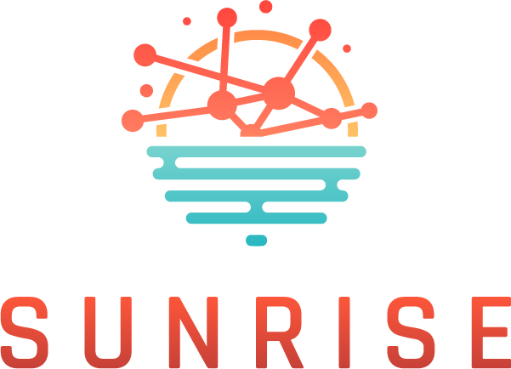
Strategies and Technologies for United and Resilient Critical Infrastructures and Vital Services in Pandemic-Stricken Europe

Online Cross-border collaboration Workshop 6.6.2024; 09.00-13.00
Agenda - draft

09.00-09.15: Online WS Welcome opening and Agenda introduction (ICS)
09.15-09.30: Introduction & keynote address (EC DG Home)
09.30-10.00: SUNRISE Project introduction (ATS/Project coordinator)
10.00-10.15: Coffee/Technical break – Plenary session is divided into virtual tables/sessions
10.15-11.45: Virtual tables/sessions discussions moderated by Cluster Leads ICS, UPM and INS & Vice Leads XLB, ATS, HB: Discussions aimed at supporting cooperation on a cross-border level to exchange best practices, discuss common issues, and find means for critical infrastructure operators to better support each other in crises
11.45-12.00: Coffee/Technical break – Plenary session is resumed
12.00-12.30: Virtual tables/sessions discussions reports/key takeaways presented by moderators
12.30-13.00: Reflection and conclusion

