
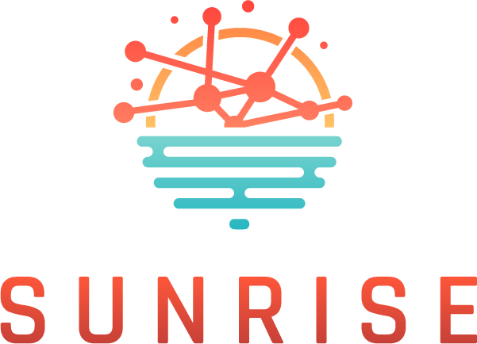
Strategies and Technologies for United and Resilient Critical Infrastructures and Vital Services in Pandemic-Stricken Europe

Online Cross-border collaboration Workshop 6.6.2024; 09.00-13.00
Agenda - draft

08.45-09.00: Online event registration
09.00-09.15: Online WS Welcome opening and Agenda introduction (Milan/ICS)
09.15-09.30: Introduction & keynote address (EC DG Home) - pending
09.30-10.00: SUNRISE Project introduction (Aljosa/Project coordinator)
10.00-10.20 Strategy for Awareness and Resilience of CIs (Max/WP2)
10.20-10.35: Coffee/Technical break – Plenary session is divided into virtual tables/sessions
10.35-12.00: Virtual tables/sessions discussions moderated by Cluster Leads INS (Gilda), UPM (Jose Miguel) and ICS (Marko, Milan) & Vice Leads XLB, ATS, HB: Discussions aimed at supporting cooperation on a cross-border level to exchange best practices, discuss common issues, and find means for critical infrastructure operators to better support each other in crises - WP2 ppt & que related discussion
12.00-12.15: Coffee/Technical break – Plenary session is resumed
12.15-12.45: Virtual tables/sessions discussions reports/key takeaways presented by moderators INS (Gilda), UPM (Jose Miguel) and ICS (Marko, Milan)
12.45-13.00: Reflection and conclusion (Aljosa/Project coordinator)

