
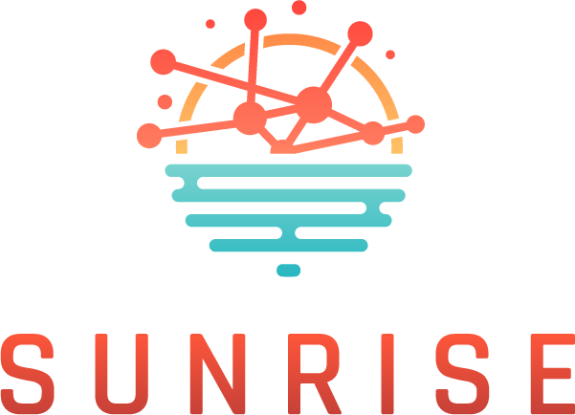
Strategies and Technologies for United and Resilient Critical Infrastructures and Vital Services in Pandemic-Stricken Europe

Online Cross-border collaboration Workshop 6.6.2025; 09.00-13.00
Agenda

09.00-09.15: Welcome & Agenda Introduction (ICS)
09.15-09.30: Introduction & keynote address (EC DG Home)
09.30-10.00: SUNRISE Project Introduction & Overview & Status (Project Officer & Coordinator)
10.00-10.30: WSs Discussion topics presentations (AIT&HB, ICS, UPM)
10.30-10.45: Coffee/Technical break
10:45-12:00 Virtual Table Discussions: Best practices, challenges, and cross-border crisis support strategies
12.00-12.15: Coffee/Technical break
12.15-12.45: Moderators of the Virtual Tables share sessions takeaways
12.45-13.00: Reflection and conclusion (SUNRISE Project Coordinator)

